**Online exam instructions for students**

Introduction 2

How to access Google Docs templates for examination answer sheets 2

How to include photographs or pictures in your answer 5

Google Photos 5

Snipping Tool 5

Microsoft Word 7

Google Docs 7

How to type in Japanese 9

Microsoft Word 9

Google Docs 9

How to type in other languages that use accents (e.g. French or Spanish) 10

Microsoft Word 10

Google Docs 11

How to include graphs in your answer 13

Microsoft Word 13

Google Docs 15

How to include diagrams in your answer 18

Microsoft Word 18

Google Docs 19

How to include mathematical formulae and calculations 21

Microsoft Word 21

Google Docs 21

# Introduction

In this document you will find instructions on how to complete your exams electronically, in both Microsoft Word 2016 and Google Docs. If you are using a different version of Microsoft Word the functions available may be different.

**Please note that these instructions are purely suggestions – there are many methods for completing the tasks listed below, so if you prefer to use another solution please do so.**

# How to access Google Docs templates for examination answer sheets

Microsoft Word templates for examination answer sheets will be available via Moodle along with the other exam materials. If you do not have access to Microsoft Word, there are Google Doc templates for Multiple Choice and Written examinations. To access these, go to the [Google Docs homepage](https://docs.google.com/) – this can also be accessed in the Google Apps menu, as shown below:  
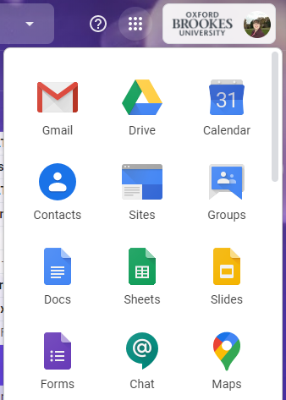

Make sure you are logged in to your Google@Brookes account and click on **Template gallery**:  
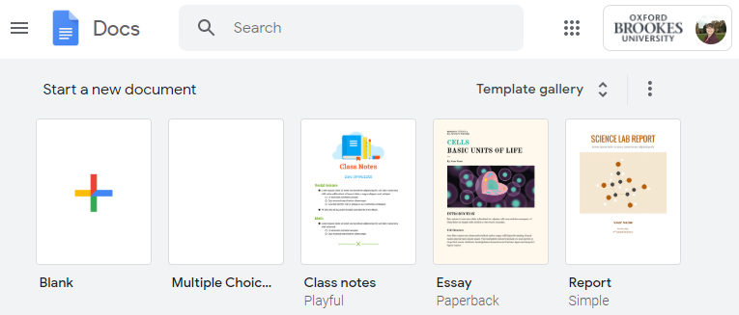

In the **Basics** section, you will see two templates – **Answer Sheet – Multiple Choice template** and **Answer Sheet – Written Exam template**. Click on the one you want to use:   
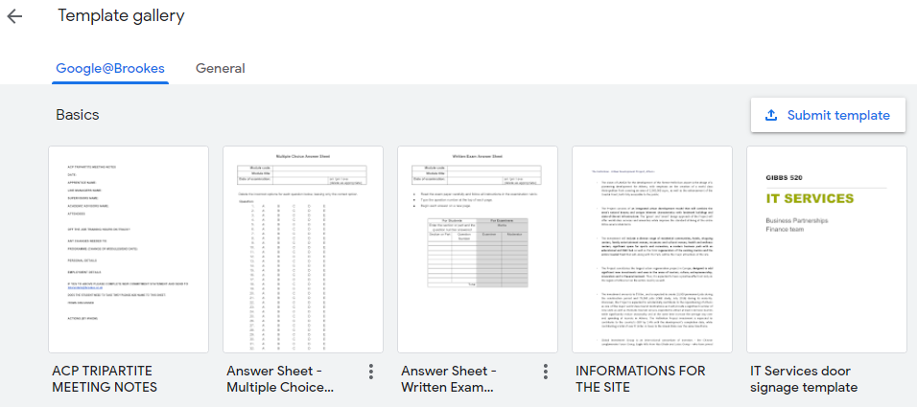

A copy of the template will then be added to your Google Drive main folder for you to complete:  
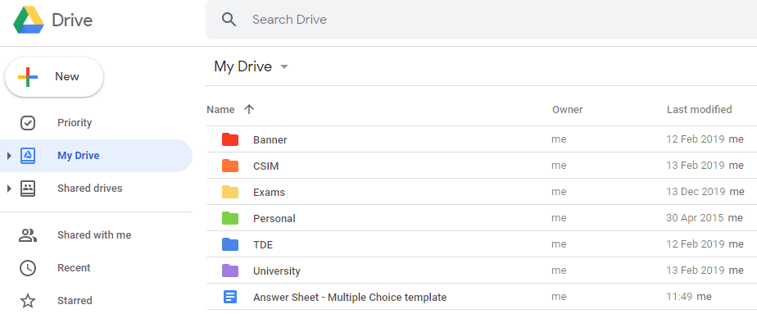

Follow the instructions for uploading your completed answer sheet to Moodle.

# How to include photographs or pictures in your answer

## Google Photos

Your Google@Brookes account includes access to Google Photos, which can be configured to automatically sync photographs taken with a mobile phone to your Google account. To set this up, you need to have the Google Photos app installed on your phone through the Play Store (for Android) or the App Store (for iPhone).

Once you have installed Google Photos, you need to set it to [sync photographs to your Google@Brookes account](https://support.google.com/photos/answer/6193313?co=GENIE.Platform%3DAndroid&hl=en). Once you have done this, you can access and download your photographs via the Google Apps menu:  
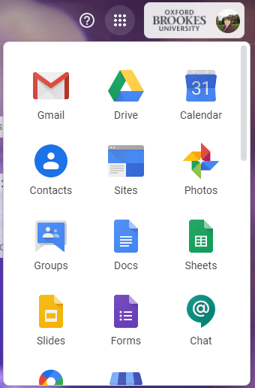

## Snipping Tool

If the picture you want to include is available on your PC, you can use the **Snipping Tool** to take a screenshot, and then following the instructions below on how to insert it into a Word document or Google Doc. The Snipping Tool can be found in the **Windows Accessories** folder in the Start menu:  
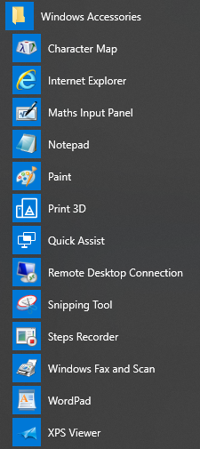

Navigate to the window you want to take a screenshot of, then open the Snipping Tool and click **New**:  
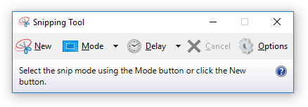

Drag the cursor around the area of the screen you want to capture. You can then copy and paste the screenshot into your answer sheet.

## Microsoft Word

Select the location in the document where you want to insert a photo or picture. Click on the **Insert** tab, and then on **Pictures**:  
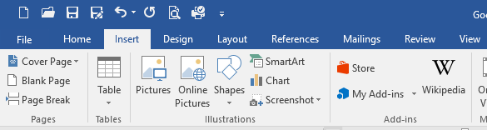

Navigate to the folder on your PC where your photos/pictures are saved, and select the picture you want to insert, then click **Insert**:  
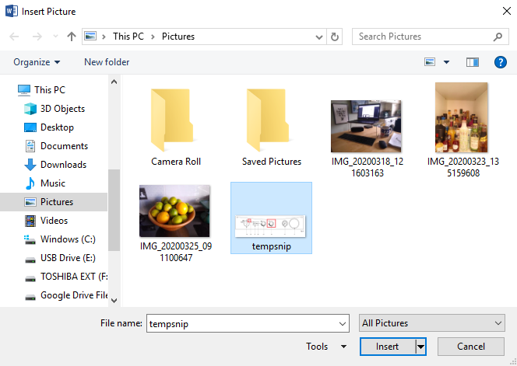

## Google Docs

Select the location in the document where you want to insert a photo or picture. Click on the **Insert** tab, and then on **Image**:  
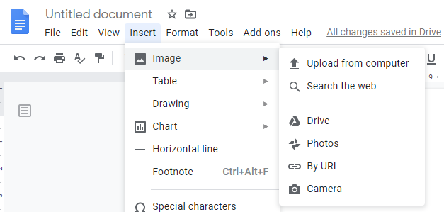

Then select where the picture is stored (e.g. **Upload from computer** if it is on your PC, or **Photos** if it is in your Google Photos), click on the picture you want to insert and click **Insert**.

# How to type in Japanese

## Microsoft Word

Please see these instructions on [how to type in Japanese](https://www.tofugu.com/japanese/how-to-type-in-japanese/) in Microsoft Word. There are also instructions on [how to install a Japanese keyboard](https://www.tofugu.com/japanese/how-to-install-japanese-keyboard/).

## Google Docs

To access the Japanese Input Method Editor in Google Docs, follow the instructions below.

1. Go to [myaccount.google.com/](https://myaccount.google.com/).
2. Go to **Data and personalisation** > **General preferences for the web**.
3. Click on **Input Tools**, and then click **Add Language**.
4. Add the languages that you need and select **Input Method Editor**.
5. Scroll down and under **Options** tick the box for **Keep dictionary synchronised between Google services**.

In Google Docs, go to **File** > **Language** and select the language you need. Once you have it set up under Input Tools in [myaccount.google.com/](https://myaccount.google.com/) as outlined above, you should be able to easily switch between languages, including the dictionary.

# How to type in other languages that use accents (e.g. French or Spanish)

## Microsoft Word

Select the location in the document where you want to insert the accented letter. Click on the **Insert** tab, and then on **Symbol**:  
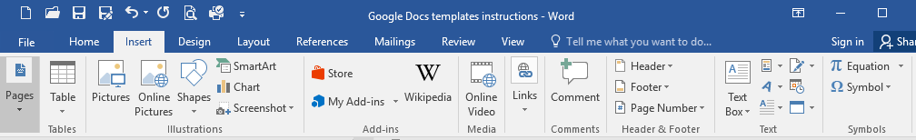

Click on **More Symbols**:  
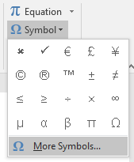

Select the correct font, then select the accented letter you want to use and click **Insert**:  
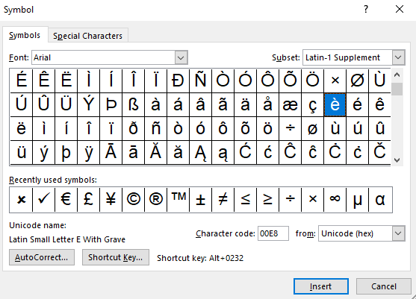

You can keep the Symbol menu open and continue typing as normal, to save having to reopen it every time you want to insert an accented letter.

## Google Docs

Select the location in the document where you want to insert the accented letter. Click on the **Insert** tab, and then on **Special characters**:  
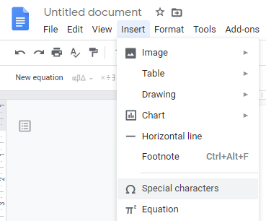

The **Insert special characters** dialog will appear – click to select the accented letter you want to insert into your document:  
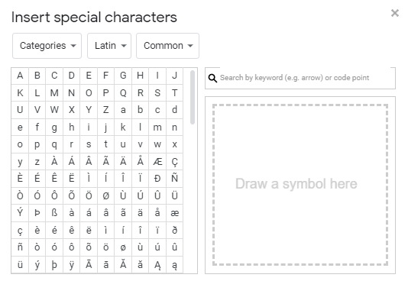

You can keep the Special Characters menu open and continue typing as normal, to save having to reopen it every time you want to insert an accented letter.

# How to include graphs in your answer

The simplest method for including graphs in your answer would be to hand draw them and then take a photograph, which can be inserted into your answer paper – see the instructions above on including photographs and pictures.

## Microsoft Word

You can create graphs within Microsoft Word. Select the location in the document where you want to insert the chart. Click on the **Insert** tab, and then on **Chart**:  
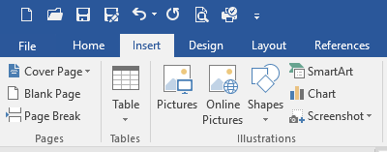

Select the type of graph you want to include, and click **OK**:  
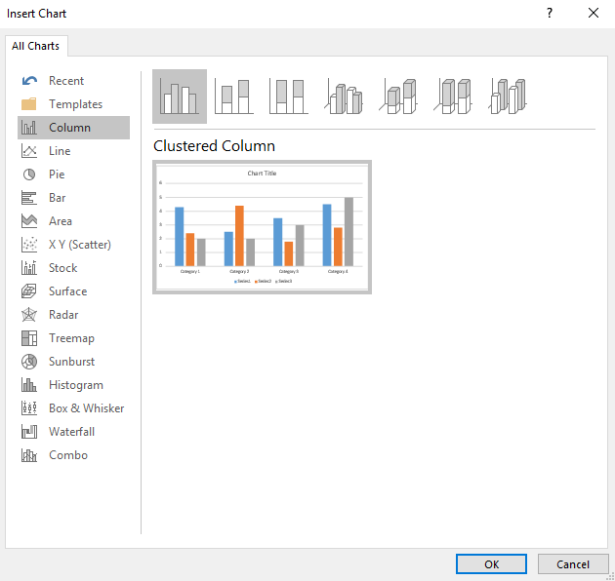

Edit the fields to create the graph you want to include:  
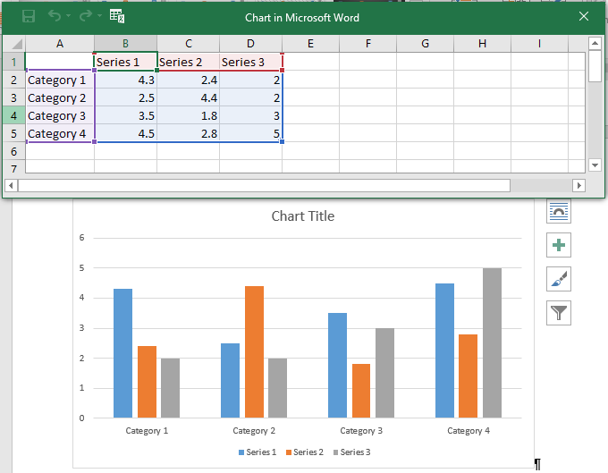

## Google Docs

Select the location in the document where you want to insert a graph. Click on the **Insert** tab, and then on **Chart**, then select the type of graph you want to include:  
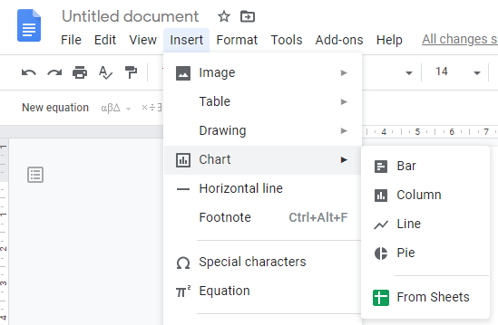

To edit the fields to create the graph you want to include, click to select the graph and then click the **Link** symbol in the top right corner and select **Open source**:  
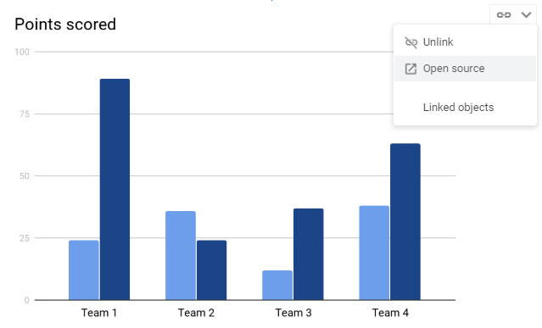

This will open a Google Sheet where you can amend values and other information:  
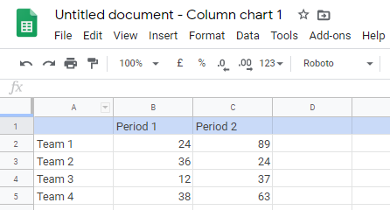

# How to include diagrams in your answer

The simplest method for including diagrams in your answer would be to hand draw them and then take a photograph, which can be inserted into your answer paper – see the instructions above on including photographs and pictures.

## Microsoft Word

You can create graphics using the SmartArt option within Microsoft Word. Select the location in the document where you want to insert the graphic. Click on the **Insert** tab, and then on **SmartArt**:  


Select the type of SmartArt graphic you want to include, and click **OK**:  
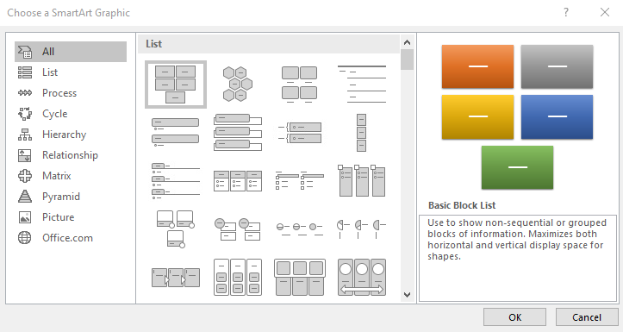

Edit the fields to create the graphic you want to include:  
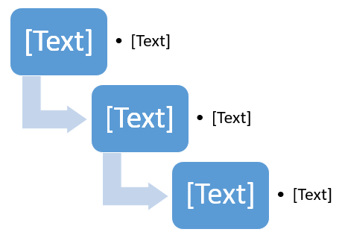

## Google Docs

Select the location in the document where you want to insert a diagram. Click on the **Insert** tab, and then on **Drawing**:  
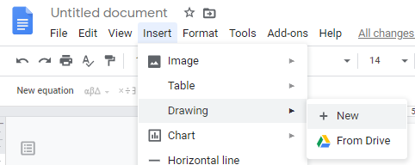

Click **New**, and a dialog box will appear where you can create a graphic using Shapes and Connectors. Click **Save and Close** to insert the graphic into your answer sheet:  
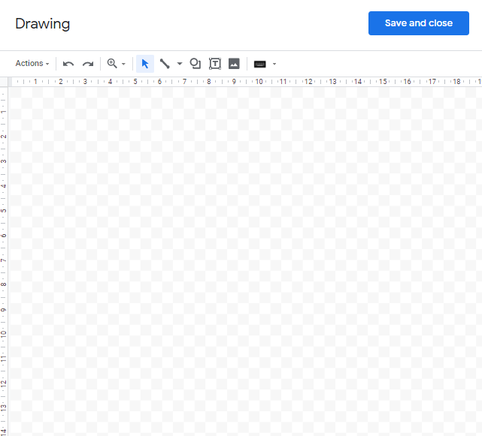

# How to include mathematical formulae and calculations

The simplest method for including mathematical formulae and calculations in your answer would be to hand write them and then take a photograph, which can be inserted into your answer paper – see the instructions above on including photographs and pictures.

## Microsoft Word

To type an equation in Word, select the location in the document where you want to insert the equation. Click on the **Insert** tab, and then on **Equation**:



Use the **Equation Tools Design menu** to create your equation:

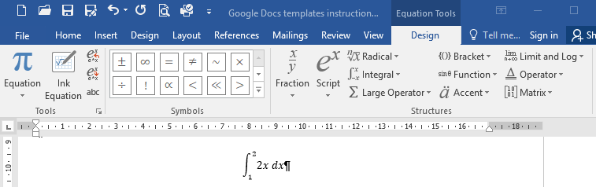

## Google Docs

To type an equation in Google Docs, select the location in the document where you want to insert the equation. Click on the **Insert** tab, and then on **Equation**:

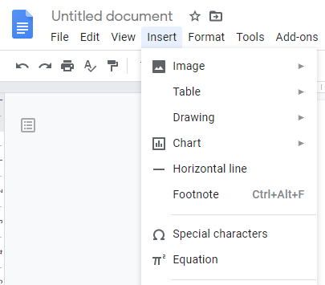

Use the **Equation toolbar** to create your equation:

